SE Uplift Board Packet

Welcome to the SE Uplift Board of Directors! We hope the information in this packet will help you become familiar with SE Uplift and your role as a board member.

SE Uplift is one of seven neighborhood coalitions in the Portland Neighborhood System. We provide services and support to 20 neighborhoods in inner southeast and northeast Portland. Though we receive most of our funding from the City of Portland, via a grant managed by the Portland Office of Community and Civic Life, we are an independent non-profit corporation.

As a SE Uplift board member, you have two important roles:

- Serve as a liaison between SE Uplift and your neighborhood, organization, or community: Learn more about the programs and services available from SE Uplift and serve as an ambassador for SE Uplift in the larger community. Additionally, help ensure that SE Uplift is responsive to community needs.

- Contribute to oversight and governance of the SE Uplift corporation:
As a member of a non-profit board, you have both the opportunity and responsibility to contribute to financial and organizational governance. Operations and administrative decisions are made by the SEUL Executive Director and staff, and strategic planning, mission, and large-picture visioning falls into the domain of the board.

We know that new board members sometimes feel overwhelmed by the amount of information and the complexity of issues that coalitions deal with. In addition to familiarizing yourself with the information in this packet and on our website, we encourage you to ask lots of questions. SE Uplift staff and other board members are excited to welcome you aboard and happy to provide any additional information you may need. We look forward to working with you on the board!

Sincerely,

Leah Fisher
Interim Executive Director
Tina Kimmey
Board Chair

Overview of Board Membership at SE Uplift

SE Uplift’s Mission

To collaborate with the SE Portland community to build informed, inclusive, and participatory neighborhoods that support our social and ecological well-being.
- SE Uplift also joyfully supports Northeast neighborhoods south of I-84

Our Values
- Relationship-Building: Personal connections and networks strengthen our communities.
- Community Involvement: Organized neighbors can shape the future of our communities, including envisioning and enacting positive change. Through collaboration, we co-create the communities we want to inhabit.
- Grassroots Democracy: We all have a role in determining the character and future of our city through grassroots, bottom-to-top participation.
- Sharing, Teaching and Learning: With tools, support, and opportunities to connect, we can effect positive change.
- Diversity and Inclusiveness: In an inclusive, multicultural environment, through which we can explore our differences and come together around common interests and goals.
- Building Capacity: We strengthen our communities as we strengthen our neighborhood associations, community-based organizations, and business districts.

Declaration of Unity
The Southeast Uplift Neighborhood Program Board of Directors affirms the rights of all neighbors to live and work without fear of intolerance because of their age, disability, income, gender, religion, sexual orientation, or their ethnic, racial or national origin. We honor and encourage the diversity within our neighborhoods and strive to have full participation from all our various groups on our board.

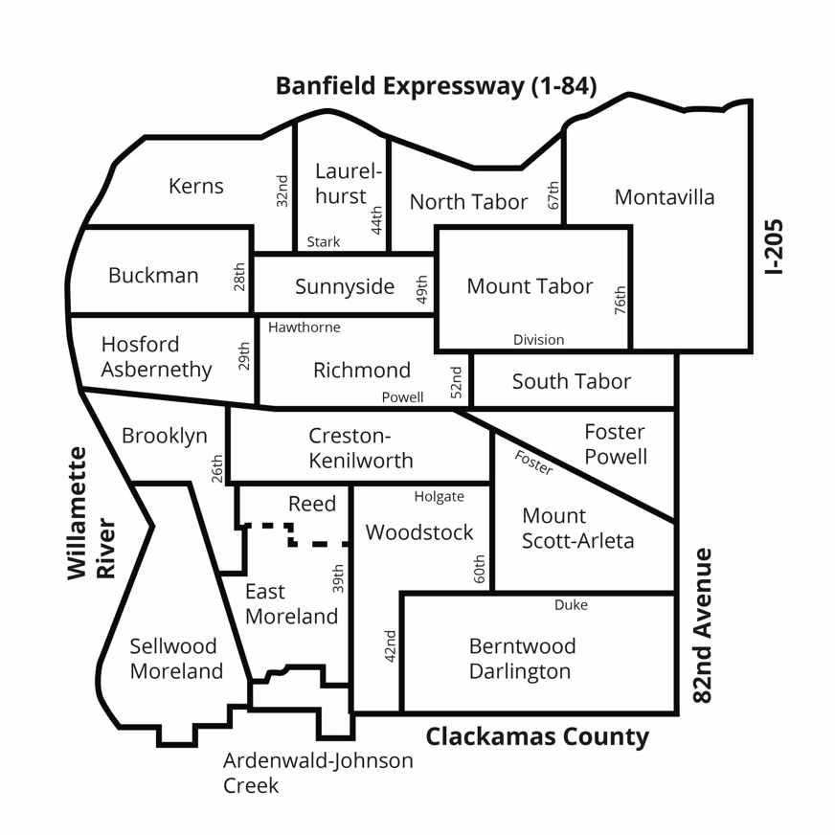
Board of Directors Description
The SE Uplift Directors are representatives of member neighborhood associations as well as community members who reside in, own a business in, or represent a business, nonprofit, or agency within the SE Uplift boundaries. The Board of Directors consists of up to one director elected by each member neighborhood association, up to two directors representing area business association, up to 5 directors representing community-based organizations, and up to five at-large directors.

Benefits of Serving as a SE Uplift Board Member
Board members at SE Uplift have access to the following opportunities and benefits:

- Share, support, and troubleshoot with leaders of surrounding neighborhood associations and community groups
- Have a direct impact on SE Uplift direction and programming
- Support your neighborhood and community by shaping SE Uplift and the services we provide
- Gain valuable leadership skills such as facilitation, strategic thinking, and conflict resolution
- Learn about a variety of non-profit management areas including finance, human resources, fundraising, and policy development
- Engage in city policy discussions and impact advocacy efforts

Board Member Responsibilities, Commitments, and Duties
As discussed at the beginning of this packet, the Board of Directors is responsible for leadership, governance, and oversight of SE Uplift. Our organization has an annual budget of approximately $500,000 and around 4-5 paid staff members. The board sets the policies of the organization and reviews all policy or advocacy requests made of the organization – approving or denying them by vote at an open board meeting. They approve the annual budget, review the financial reports, and hire the Executive Director. The Executive Committee, consisting of the officers of the organization and a past chair, provides primary administrative governance of the organization. Executive Committee members review and make recommendations to the full board on any significant out-of-budget expenditures. They also support, oversee, and review the Executive Director, as well as review and approve fiscal sponsorship applications, personnel policy changes, and more.

Statement of Purpose
Each director shall endeavor to promote the objectives of SE Uplift to the best of their ability. Each is expected to attend board meetings, to effectively communicate between the Board and the organization they may represent, and, to personally promote and participate in the organization’s activities. More information about the responsibilities of board members can be found in the next section.

Commitments
As a board member you are committing approximately 3-7 hours per month in this role, and are agreeing to the following commitments:

- Attend SE Uplift’s 2-hour monthly board meeting held the first Monday of the month (except in August).
- Attend an orientation to learn more about your role as a board member of a non-profit. (Trainings are offered by SE Uplift periodically).
- Review and sign onto to SE Uplifts Diversity, Equity, Inclusion, and Accessibility (DEIA) Statement and DEIA Code of Ethics.
- Periodically volunteer extra time and energy to support SE Uplift by participating in board committees, supporting SE Uplift events and programming, and generally acting as a spokesperson for the organization.
- Agree to govern the organization and uphold its mission and values

Duties
SE Uplift Board Members are required to follow all state laws that govern nonprofit organizations and board members. This includes showing up, avoiding conflicts of interests, governing the organization to the best of your ability, and upholding the mission and values in all polices, programs and practices. This includes, but is not limited to:

- Meeting your Duty of Care, Duty of Loyalty, and Duty of Obedience as board members
- Governing in the best interest of SE Uplift and its future
- Assuring the coalition’s services and programs are responsive to all community concerns and interests
- Engage neighbors in coalition programs and projects
- Engage neighborhood associations, community groups, and neighbors in big picture vision, goals, and projects to strengthen our community for everyone in our coalition area
- Serve as an advocate in the public policy arena concerning land use, environmental, transportation, social justice, and other livability issues
- Participate on Board Committees as needed
- Consider serving as an officer of the board (ie. Chair, Vice Chair, Treasurer or Secretary)
- Overseeing administrative responsibilities required for the organization to function and thrive, such as overseeing the coalition’s finances, conducting strategic planning, support the hiring of an Executive Director, and meeting the requirements of the annual grant received from the City of Portland
Additional Resource: Guide to Nonprofit Board Service in Oregon. This guide from the Oregon Department of Justice outlines Board members’ rights, roles, and responsibilities.

Board Meetings
Board meetings are usually held on the first Monday of the month from 7 pm – 9 pm. Meetings impacted by COVID-19 are all held virtually via Zoom, otherwise meetings are held in the Fireside Room at SE Uplift’s 3534 SE Main St location in Portland.

Executive Committee Meetings
The SE Uplift Board of Directors’ Executive Committee meets monthly on the third Wednesday, 6 pm – 8 pm, on the second floor at SE Uplift, 3534 SE Main Street. During COVID-19, all meetings are held virtually until further notice. Voting at Executive Committee meetings is restricted to committee members.

The Executive Committee, consisting of the officers of the organization and a past-chair, provides primary administrative governance of our organization. Executive Committee members review and make recommendations to the full SE Uplift Board on any significant out-of-budget expenditures, support, oversee and review the Executive Director, and review and approve fiscal sponsorship applications, personnel policy changes and more. Executive Committee has the authority of the Board of Directors to make decisions on routine and emergency business items. All actions taken by the Executive Committee are reported to the full Board.

Other Board Committees
SE Uplift Board members are able to join a variety of committees that help steer our organization, such as our Land Use and Transportation Committee, Board Development Committee, and Houselessness Action Committee. Please view the Committee’s page on our website for descriptions, meeting dates, and more. Many committees are looking for additional members so please don’t hesitate to reach out and get involved!

SE Uplift Programs & Services
As a board member, it will be helpful to understand the various services our organization offers to the community. This next section discusses those services in detail.

Community Liaison Services
We provide the following base level of support to NAs and other groups who meet eligibility criteria:
- Attend neighborhood meetings twice a year to support the annual elections process and share information.
- Conducts board member orientation by providing resource materials at elections, invitations to trainings, and hosting bi-annual new board member orientations.
- Support annual election preparation by providing process and communication resources.
- Send reminders on, and provide assistance with, submitting communication funds proposals and reimbursement requests.
- Send reminders and provide assistance to ensure compliance with annual fillings requirements.
- Connect members with appropriate bureau(s), organizations, resource(s), other SE Uplift program staff, and other volunteers when a need is identified.
- Help answer organizational process, structural, policy, or procedural questions and share best practices in areas we have knowledge/expertise.

Upon request, and depending on availability, liaisons may also be able to do the following additional support:
- Lead or assist with an annual visioning or goal setting session.
- Promote neighborhood events through SE Uplift’s communication channels.
- Consult on strategy and planning for various events or trainings.
- Connect you and your board with other NA leaders for resource and information sharing; trainings and resources offered by the City and partner organizations; and advocacy efforts and resources at the coalition and city-level.
- Attend additional neighborhood association meetings when a need is present.
- Brainstorm and/or support: community building efforts; communication strategies; diversity, equity, inclusion efforts, and other efforts to increase civic engagement, leadership development, and community building.
- Work with neighborhoods to capture information and data to use in: reports, best practices, toolkits, and more.
- Help with trouble-shooting other organizational issues or barriers the NA comes across.

Funding and Support for the SE Community

Communication Funds
Communications Funds are intended to support NAs with communication efforts. This includes to generate awareness of, and participation in neighborhood activities and events, provide residents with information about local issues, and to build relationships between neighbors.

Neighborhood associations are eligible to apply for $500.00 in funding for communications-related expenses. Neighborhood Associations are required to fill out a short fund application, if they want to receive the funds. Should you choose to apply for this funding, we expect neighborhood associations to prioritize the use of these funds to meet a minimum standard, or baseline, of communication.

*Note: these funds are not a guarantee.

Communication Grants
Depending on funding availability, communications grants are available to all community organizations including (but not limited to) neighborhood associations serving the Southeast Portland community via a small competitive grant process. Grants fund similar efforts and purpose as the Communication Funds, except these are competitive and open to the entire Southeast Community. Since 2019, SE Uplift has awarded Communications Grants of up to $1000. Grants will continue to be made available for NAs and community groups as funding is available.

Small Grants
SE Uplift is sometimes able to provide grant opportunities for our NAs. Past grant programs have included Neighborhood Small Grants, Graffiti Abatement Grants, and Creative Engagement Grants. When grants are available, SE Uplift will notify NAs through our e-newsletter. For inquiries about the Community & Civic Engagement Small Grants Program please contact our Community Liaison Program Manager.

Fiscal Sponsorship
SE Uplift can provide your NA with fiscal sponsorship, which will allow you to apply for grants and solicit tax-deductible donations under SE Uplift’s 501c3 tax-exempt status. To use SE Uplift’s tax-ID, NAs must first apply and be approved for each specific project or event. To simplify this process, NAs can submit one application for all expected projects and events for the year. Sponsorship lasts for one year and updates are required anytime a grant is applied for.

Once approved, ALL financial donations generated using SE Uplift’s tax-ID must be deposited in your NA’s designated account at SE Uplift. ALL in-kind donations generated using SE Uplift’s tax-ID must be tracked and reported to SE Uplift. To find out which of your NA’s projects currently have fiscal sponsorship, get assistance with the application process, or discuss the reimbursement process, please contact our Community Liaison Program Manager.

Other SE Uplift Programs

Events, Training, and Workshops
SE Uplift hosts informational workshops, skill-based trainings for neighborhood volunteers, and events designed to increase our visibility and the public’s understanding, support, and engagement with SE Uplift’s mission. Examples of previous events include:

- Demolition, Infill and Housing Affordability Forum
- Knock, Knock! It’s Your Neighbor
- Grants Celebrations
- Inclusionary Housing Workshop
- Board Member Orientations
- Ground Rules Training
- Good Neighbor Agreement Trainings
- Volunteer Appreciation Parties
- Quarterly Sustainability Workshops Highlighting Community Projects
SE Uplift also has space and equipment rentals available to NAs and community groups who want to facilitate their own events. Please contact the Operations Manager for more information on space and equipment rentals.

Land Use & Transportation
SE Uplift’s Neighborhood Planning program supports residents in playing an active role in land use and transportation issues in their neighborhoods. Whether it is advocating for a new crosswalk, examining ways to improve an unimproved street, or advice on how to negotiate transportation decision making at the city, SE Uplift can support you and your neighborhood. For support with land use, transportation, or development issues contact the SE Uplift Neighborhood Planning Program Manager.

Online Resources for Board Members

Website
Our website hosts vital information about our organization and programs. Under the “Who We Are” menu, you will find a page devoted to the SE Uplift Board with links to meeting dates, agendas and meeting minutes, a board roster, bylaws, letters of support and advocacy, and this full board binder. Other great resources on our website include our Events Calendar and a Community Resource Library with information on neighborhood elections, outreach, meeting facilitation, and more!

Facebook and Instagram
We have updated our approach to social media by creating a cohesive visual language through consistent use of a branding guide. Through our Facebook and Instagram account you can find flyers to the latest events happening throughout SE Portland and stay up to date on news and resources. Visit us at @seuplift on Facebook and Instagram.

Newsletters
Be sure to sign up for both SE Uplift’s monthly E-news. You can sign-up on our homepage.

Board Listserv
The SE Uplift Board uses an Outlook group email list to communicate about board business and distribute announcements to the full board. You will automatically be added to this as a new board member.

