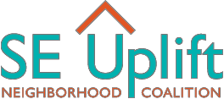Applications must be received by February 8, 2019. A complete grant application must include the following components: cover page, narrative, budget, proof of eligibility document(s), and letters of support from partner organizations (if applicable).
Please review the application handbook before completing the application.

2019 Community and Civic Engagement Small Grants
– Cover Page –

Project Name:

Applicant Organization / Group:

Applicant Organization Nonprofit Status: Please select one of the options below and include the associated proof of eligibility documents with your application.

[Attach IRS nonprofit determination letter]
- 501(c)3 Organization

[Attach fiscal sponsor’s IRS nonprofit determination letter and fiscal sponsorship verification form]
- Fiscally Sponsored by 501(c)3 Organization

[Attach SE Uplift fiscal sponsorship request form]
- Applying for Fiscal Sponsorship with SE Uplift

Project Coordinator:
Phone: |  | Email:
Mailing Address:
City, State, Zip:

Partner organization(s) [if applicable]:

Requested Funding Amount:

Project Summary: Briefly (75 words or less) summarize the activities and objectives of your project, involvement of key partners, and anticipated outcomes. Please use full sentences.

